Data Sheet
Control lysates
Vial contents: 100 μl of cell lysate in Laemmli sample buffer. Ready to use.
Storage: The lysate is stable at -20ºC for at least 6 months. For long-term storage, prepare aliquots and store at -80ºC. Avoid repetitive freeze thaw cycles.
Recommended working dilutions:
  - Western Blots: 5-10 μl per gel lane
It is suggested the investigator determine a suitable working concentration empirically for each assay utilized. Suitability for a specific application should be determined by the investigator.

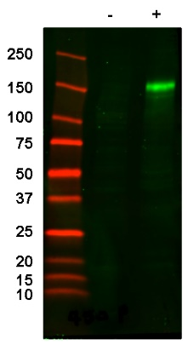
Figure 1: Western Blot of 10 ul CFTR Negative (-) and Positive (+) control lysates using mAb 596P.

