Data Sheet
Antibody 154
Antigen: Peptide to CFTR amino acid sequence 426-433
Antigenic Site: RI region of NBD1
Antibody Class: Mouse IgG_{2a}
Vial contents: 200 μl of ascites and 50% glycerol solution containing 0.05% azide as preservative.
Storage: The antibody is stable at -20ºC for at least 6 months. For long term storage, prepare aliquots and store at -80ºC. Avoid repetitive freeze thaw cycles.
Recommended working dilutions:
  - Western Blots: 1:500-1:1000
  - Immunochemistry: NA
It is suggested the investigator determine a suitable working concentration empirically for each assay utilized. Suitability for a specific application should be determined by the investigator.
The antibody has been tested in Western blots against 10 μg crude membrane proteins prepared from BHK cells expressing CFTR (Figure 1).
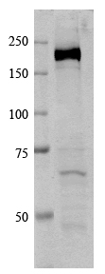
Figure 1: Western Blot of CFTR . Detected using Li Core Odyssey Infrared imager.

