Data Sheet
Antibody 660
Antigen: Purified, full length CFTR
Antigenic Site: NBD1
Antibody Class: Mouse IgG_{2b}
Vial contents: 200 μl of ascites as a 50% glycerol solution containing 0.05% azide as preservative.
Storage: The antibody is stable at -20ºC for at least 6 months. For long term storage, prepare aliquots and store at -80ºC. Avoid repetitive freeze thaw cycles.
Recommended working dilutions:
  - Western Blots: 1:500 to 1:2000
  - Immunochemistry: 1:250 to 1:1000
It is suggested the investigator determine a suitable working concentration empirically for each assay utilized. Suitability for a specific application should be determined by the investigator.
The antibody has been tested in Western blots against 10 μg crude cell lysate prepared from a cell line over expressing CFTR (Figure 1).
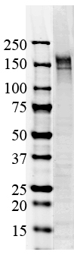
Figure 1: Western Blot of CFTR . Ab dilution 1:1000. Detected using Li Core Odyssey Infrared imager.

