Data Sheet
Antibody 1I22
Antigen: Purified, full length CFTR
Antigenic Site: R-Domain
Antibody Class: Mouse IgG_{2b}
Vial contents: 200 μl of ascites as a 50% glycerol solution containing 0.05% azide as preservative.
Storage: The antibody is stable at -20ºC for at least 6 months. For long term storage, prepare aliquots and store at -80ºC. Avoid repetitive freeze thaw cycles.
Recommended working dilutions:
  - Western Blots: 1:500 to 1:5000
  - Immunochemistry: TBD
It is suggested the investigator determine a suitable working concentration empirically for each assay utilized. Suitability for a specific application should be determined by the investigator.
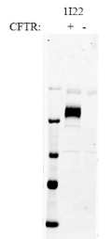
The antibody has been tested in Western blots (Figure 1).
Figure 1: Western Blot of 30 ug CFTR crude membrane. Detected using Li Core Odyssey Infrared imager.

